**NAME:ZESHAN AHMED**

**FA22-BSE-120**

**MODULE**

**View Application**

**SSD:**

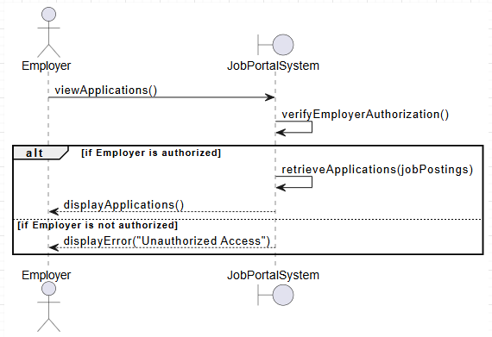

**CODE FOR SSD DIAGRAM:**

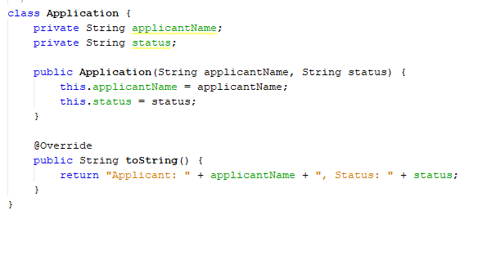

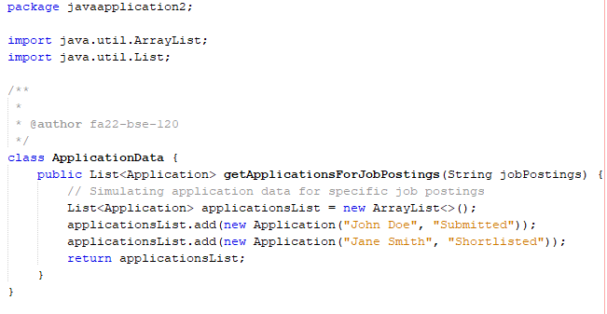

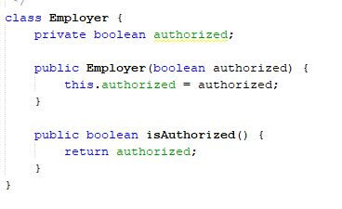

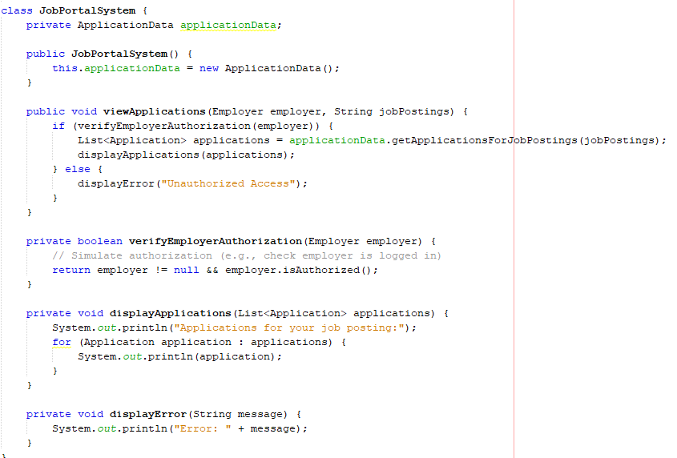

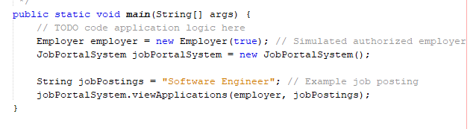

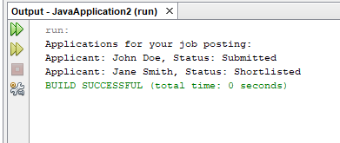

**COMMUNICATION**

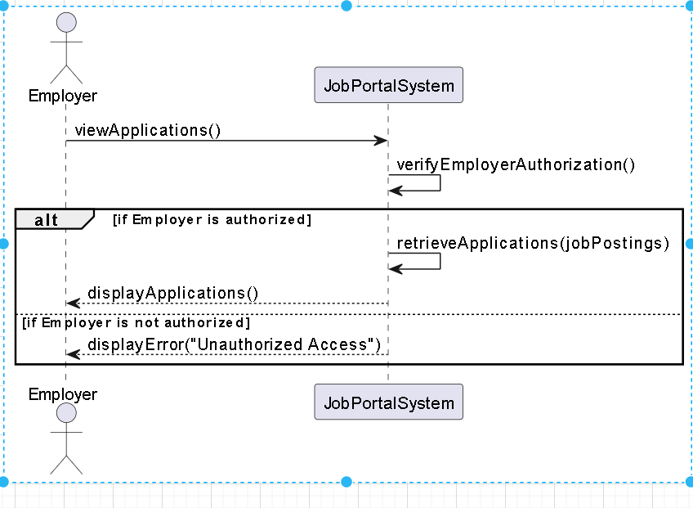

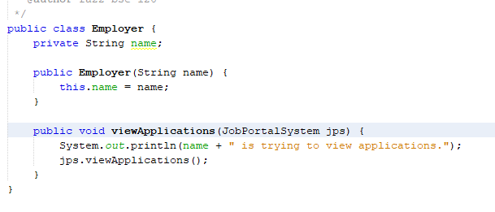

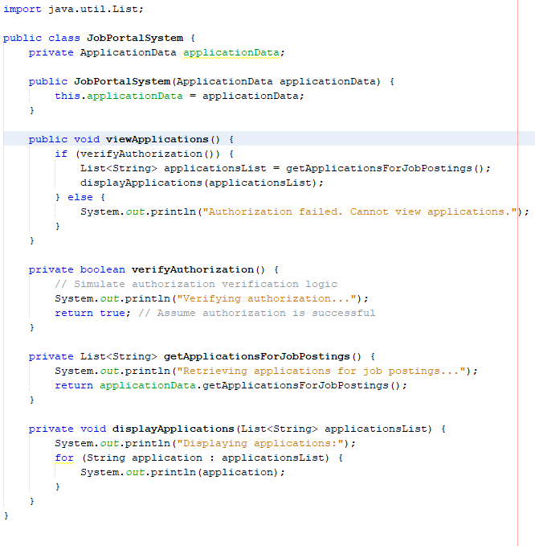

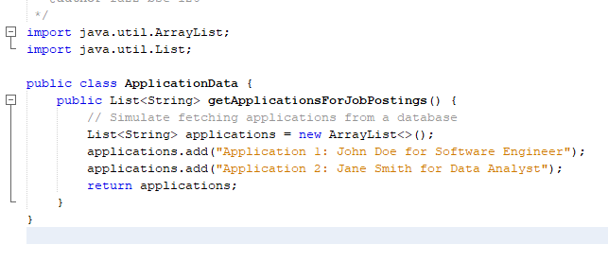

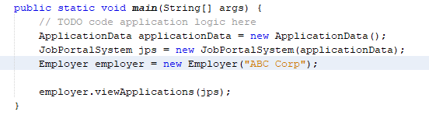

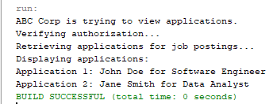

**PACKAGE DIAGRAM**

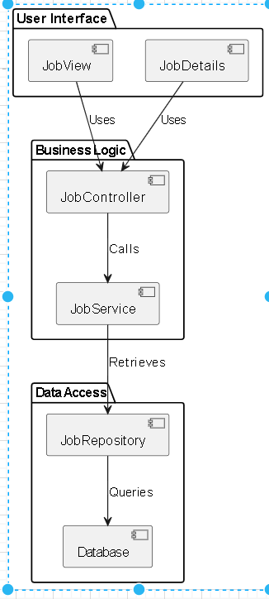

**// File: UI/ApplicationView.java**

**package UI;**

**public class ApplicationView {**

**private MainController controller;**

**public ApplicationView(MainController controller) {**

**this.controller = controller;**

**}**

**public void displayApplication() {**

**controller.initializeView();**

**}**

**}**

**package UI;**

**import ApplicationLogic.ApplicationService;**

**public class MainController {**

**private ApplicationService appService;**

**public MainController(ApplicationService appService) {**

**this.appService = appService;**

**}**

**public void initializeView() {**

**appService.processData();**

**}**

**}**

**ApplicationLogic/ApplicationService.java**

**package ApplicationLogic;**

**import DataAccess.DataAccess;**

**public class ApplicationService {**

**private DataAccess dataAccess;**

**public ApplicationService(DataAccess dataAccess) {**

**this.dataAccess = dataAccess;**

**}**

**public void processData() {**

**dataAccess.fetchData();**

**}**

**}**

**package DataAccess;**

**public class DataAccess {**

**public void fetchData() {**

**System.out.println("Fetching data from the database...");**

**}**

**}**